Imparfait vs Passé Composé

FSF2DB
Mme W-G

The passé composé expresses a completed action that occurred at a specific time in the past. This action happened at one moment in time and could have been captured by the click of an instamatic camera.

With that in mind, the following words, phrases, and expressions often require the use of the passé composé because they specify a definite past time:

l'année passée (last year) | hier soir (last night)
avant‐hier (the day before yesterday) | l'autre jour (the other day)
d'abord (at first) | ce jour‐là (that day)
enfin (finally) | un jour (one day)
ensuite (then, next) | le mois passé (dernier) (last month)
l'été/l'hiver passé (last summer/winter) | la semaine passée (dernière) (last week)
finalement (finally) | soudain/tout à coup (suddenly)
une fois (one time) | hier (yesterday)

The imparfait, on the other hand, expresses an action that continued in the past over an indefinite, undetermined period of time and could have been captured by a video camera.

The imparfait also describes what was going on in the past when another action or event took place in the passé composé: Il sortait quand je suis arrivé(e) (He was going out when I arrived.)

The following expressions generally imply repetitious or habitual past actions and, therefore, require the imparfait:

autrefois (formerly) | tout le temps (all the time)
chaque jour (semaine, mois, année) (each [every] day, week, month, year) | parfois (sometimes)
en général (generally) | quelquefois (sometimes)
de temps en temps (from time to time) | souvent (often)
d'habitude (usually) | généralement (generally)
fréquemment (frequently) | en ce temps‐là (at that time)
toujours (always) | tous les jours (mois) (every day, month)

Verbs that indicate a state of mind in the past are generally used in the imparfait.

aimer (to like, love) croire (to believe) désirer (to desire) espérer (to hope) être (to be) penser (to think)

pouvoir (to be able to) préférer (to prefer) regretter (to regret, be sorry) savoir (to know [how])

vouloir (to want)

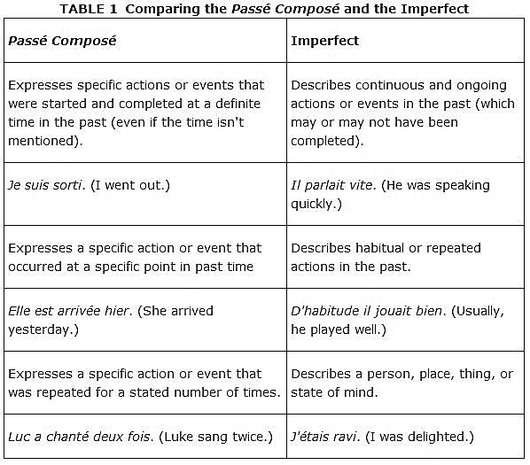

P.E.

Je lisais quand tu es arrivé(e)
Action qui interrompt
Action qui continue

