Rolling Stones Toronto SARS Concert
In what people have called the largest concert in North America, the Rolling Stones headlined a benefit in Toronto to put this city and country back on its feet after a series of hardships from SARS to Mad Cow Disease.
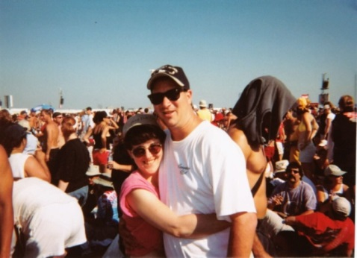
Nearly 500,000 people attended the all-day show on Wednesday, July 30 in huge Downsview Park. They were greeted by co-hosts Dan Aykroyd and Jim Belushi, then presented a full lineup of major acts: AC/DC, RUSH, Justin Timberlake, The Guess Who and Sam Roberts.
When the brilliant sun set and gave way to the night, the Rolling Stones took the stage. "We're here, you're here and Toronto is back and it's booming," Stones' singer Mick Jagger told the screaming crowd. "I think it is the biggest crowd we have ever played for."
The Stones opened with "Start Me Up." Its 90-minute set also included "Ruby Tuesday," "Honky Tonk Woman," "Satisfaction" and, the finale, "Jumpin' Jack Flash."
The crowd also loved it when Canadian '70s legend the Guess Who played Bachman Turner Overdrive's "Takin' Care of Business" earlier in the massive concert.
Event organizers, the Canadian government and the Rolling Stones all combined to donate money to fighting SARS. Canada's federal government put up $2.45 million, and the Ontario provincial government kicked in $1.4 million. Canadian brewery Molson, the chief sponsor, contributed $4.55 million, a company spokesman said.
Beer sales also went to the cause. That no doubt also raised millions.
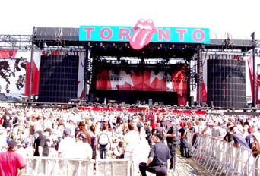 | 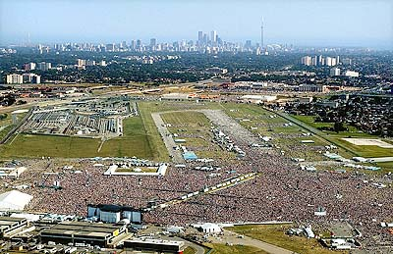 | 