FSF2DB
Mme W-G
Vocab - Bien dans sa peau!

Se coucher – to go to bed
Un journal intime – a personal journal
Plus tôt – earlier
Au cours de – in the course of
Drôle – funny
Documenter – to document, record
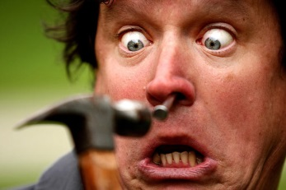
Oublier – to forget
Un clou – a nail
Six pouces – six inches
Un marteau – a hammer
S’enfoncer – to plunge, sink into
Rendre malade – to make sick
Vers – towards
Au lieu de – instead of
Être assis – to be seated
L’écran – the screen
Droit – straight
Avaler – to swallow
N’importe quoi – anything, no matter what
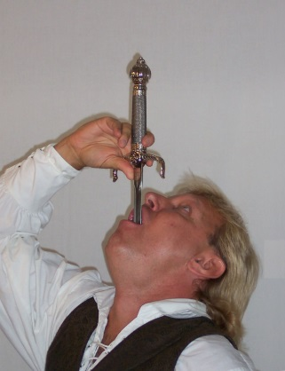
Une lame – a blade
Une épée – a sword
Dégeulasse – disgusting
Un goût – a taste
Un défi – a challenge
Pire – worse, worst

Étrange – strange
Une barbe – a beard
Une follicule – a hair
Roter – to burp
Tellement – so
Surpasser – to surpass
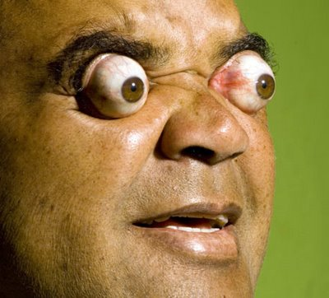
Écraser – to crush
Parmi – among
Percevoir – to sense
Jaillir – to squirt
Parcourir – to travel
Mondial – of the world
Mon âme – my soul
Ce visage – this face
Tandis que – while, whereas
Là-bas, au loin – down there, far away
Au fond – at the bottom
L’espérance – hope
Une conquête – a conquest, challenge
Une blessure – an injury
Bien dans sa peau – to feel good about oneself

