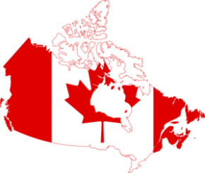
Nom: _______________________ Date: __________________
CGC1DI – La géographie du Canada et du monde
Les liens internationaux
La qualité de vie – Où en est le Canada?

Pays | Croissance naturelle  (/1000 hab.) | Pts | Mortalité infantile  (/1000 naissances) | Pts | Espérance de vie  (ans) | Pts | Alpha-bétisme  (%) | Pts | PIB par capita  ($US) | Pts | Total | Rang final
Argentine | 9.98 |  | 10.52 |  | 77.14 |  | 98.1 |  | 18 200
Australie | 5.34 |  | 4.55 |  | 81.90 |  | 99.0 |  | 42 400
Bangladesh | 16.82 |  | 48.99 |  | 70.06 |  | 56.8 |  | 2000
Canada | 2.19 |  | 4.85 |  | 81.48 |  | 99.0 |  | 41 500
Égypte | 19.42 |  | 24.23 |  | 72.93 |  | 72.0 |  | 6600
Éthiopie | 29.20 |  | 60.90 |  | 56.56 |  | 42.7 |  | 1200
France | 3.80 |  | 3.40 |  | 81.46 |  | 99.0 |  | 35 500
Japon | -0.76 |  | 2.21 |  | 83.91 |  | 99.0 |  | 36 200
Luxembourg | 3.20 |  | 4.39 |  | 79.75 |  | 100.0 |  | 80 700
Mexique | 13.97 |  | 16.77 |  | 76.66 |  | 86.1 |  | 15 300
Russie | -1.80 |  | 7.30 |  | 66.46 |  | 99.6 |  | 17 700
Afrique du Sud | 2.09 |  | 42.67 |  | 49.41 |  | 86.4 |  | 11 300
Corée du Sud | 2.04 |  | 4.08 |  | 79.30 |  | 97.9 |  | 32 400
États-Unis | 5.30 |  | 6.00 |  | 78.49 |  | 99.0 |  | 49 800
Chine | 5.15 |  | 15.62 |  | 74.84 |  | 92.2 |  | 9100

