[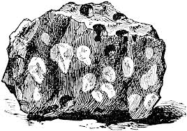](http://www.google.ca/imgres?q=rocks+clipart&hl=en&safe=active&biw=1024&bih=600&tbm=isch&tbnid=y5e8SFXuB98k7M:&imgrefurl=http://etc.usf.edu/clipart/14700/14758/amygdaloid_14758.htm&docid=Gy-jjFZb5lAJqM&imgurl=http://etc.usf.edu/clipart/14700/14758/amygdaloid_14758_lg.gif&w=1024&h=718&ei=O2BLUYrlIKemygGD34GABw&zoom=1&iact=hc&vpx=2&vpy=240&dur=4828&hovh=188&hovw=268&tx=160&ty=87&page=4&tbnh=151&tbnw=215&start=60&ndsp=24&ved=1t:429,r:78,s:0,i:321)Géo9I

Le cycle des roches

Servez-vous de la page 121 de votre texte et copiez le diagramme du cycle des roches.

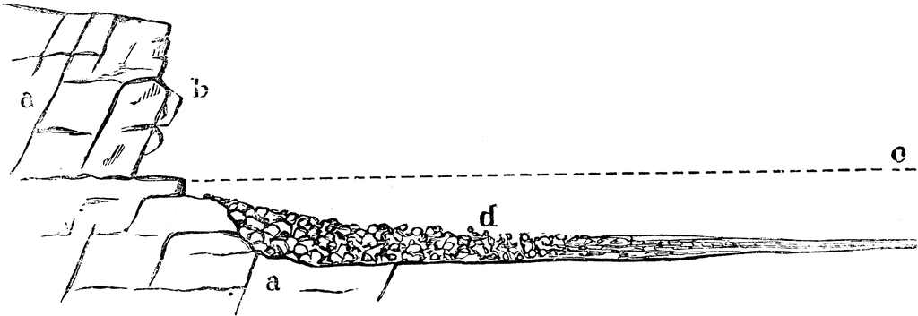[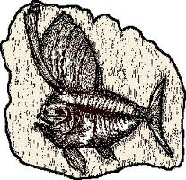](http://www.google.ca/imgres?q=fossils+clipart&hl=en&safe=active&biw=1024&bih=600&tbm=isch&tbnid=EEuYGJVIqj-2JM:&imgrefurl=http://www.lucylearns.com/fossil-pictures-fossil-clip-art.html&docid=YCa3Na110MirrM&imgurl=http://www.lucylearns.com/images/fish-fossil-clip-art-7.gif&w=259&h=251&ei=xWBLUcC7O-LfyAH3s4HIBw&zoom=1&iact=hc&vpx=2&vpy=103&dur=766&hovh=200&hovw=207&tx=89&ty=109&page=1&tbnh=141&tbnw=145&start=0&ndsp=17&ved=1t:429,r:0,s:0,i:78)