Euro Disney seeks budget increase to revive parks before key anniversary
The debt-laden theme park operator hopes a cash injection will boost flagging visitor numbers at its attractions in Paris
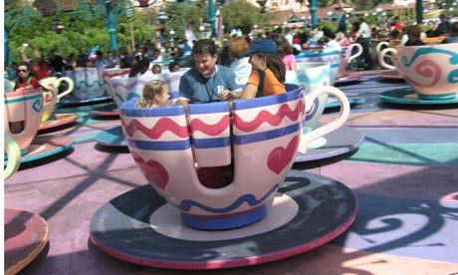
Disneyland Paris needs new rides to pull in visitors. Photograph: Picture Partners/Alamy
The Paris-based theme park operator Euro Disney is in talks with lenders about increasing its investment budget to make improvements before its 20th anniversary a year from now.
But the business, which runs the Disneyland Paris and Walt Disney Studio theme parks, is struggling with a massive debt mountain and poor visitor numbers that could undermine its fundraising move.
To make matters worse, Euro Disney is also under investigation by France's stock market watchdog after the price of its shares doubled to €9.05 (£7.95) over a 10-day period in February.
A total of 50.2% of Euro Disney's shares are publicly traded on Paris's Euronext exchange and the spike left analysts scratching their heads. As a result, celebrations for its 19th birthday on Tuesday are on ice.
In stark contrast, Disney's presence in Asia is accelerating and on Friday it broke ground on a £2.7bn park in Shanghai, the company's third park in Asia.
In Paris, however, interest in Disney is slowing down. In the year to 30 September 2010 attendance at Euro Disney's parks fell by 3% to 15m as more holidaymakers stayed at home. This led to a €2.9m drop in revenue from its theme parks but total turnover grew 3.7% to €1.3bn due to a €47m windfall from the sale of a shopping mall on its property. It gave Euro Disney an operating profit but the company was pushed into a €45.2m net loss after making repayments on the loans used to fund construction of its two parks.
Repaying its €1.9bn debt has left Euro Disney with a net loss in four of the past five years. Last year it deferred payment of €20.2m in interest owed to its biggest lender, the state-controlled Caisse des Dépôts et Consignations, as well as €25m of royalty fees to the Walt Disney Company, which owns 39.8% of Euro Disney.
This was the maximum amount the company was allowed to defer and, as a result, it was forced into negotiations with lenders over its annual recurring investment budget. This budget covers the renovation of its assets but excludes investment in new developments. Its 2010 annual report revealed that if no agreement is reached with lenders, the budget for 2011 will be around €25m under its total of €73.9m last year.
At its AGM in March the chief financial officer Greg Richart said Euro Disney was "seeking lenders' approval to increase spending for on-stage assets". "On-stage" refers to the parts of the two parks that visitors see.
Euro Disney usually celebrates major anniversaries by opening new rides to attract more visitors. Its last blockbuster launch at Disneyland Paris was the Tower of Terror, a freefall ride inside a 180ft art deco tower, which opened its doors in 2008. Three small fairground-style attractions were built last year but no new rides are due to open in the next 12 months or beyond. This is not surprising given that blockbuster rides can cost as much as €100m to build.
In October chief executive Philippe Gas announced he had set a target of paying back 25% of Euro Disney's debt by 2013: to meet this goal, the company would need to repay €475m over the next three years but Richart revealed at the AGM that only €410m is scheduled to be repaid by the end of 2013, with the annual repayment dropping to €37.4m in 2014.
Euro Disney has long hankered after a third park to boost visitor numbers and its original agreement with the French government allowed it to build a third park by 2017. In September it extended the timeframe until 2030, but one of its analysts believes a third park is unlikely to be built even within this period. Despite recent excitement over the share price, a happy ending for investors seems a long way off.

