FSF1DR
Mme W-G
C’est quoi la culture?

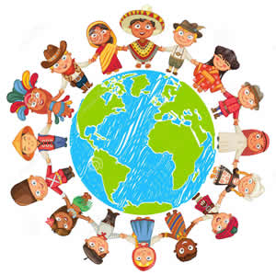

Le mot culture vient du mot latin cultura, qui veut dire cultiver. Aujourd’hui, la culture du Canada comprend des idées et des expériences de gens qui viennent de partout dans le monde. C’est notre héritage partagé! On doit respecter et apprécier la diversité culturelle. La culture comprend ces éléments spécifiques :

l’art et la littérature (aussi la musique, la danse, l’architecture),
les coutumes et les traditions (la nourriture, les traditions et les festivals, l’habillement),
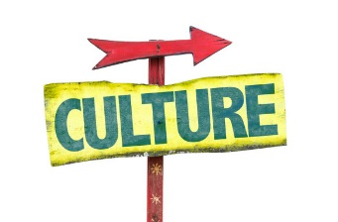
l’histoire (les origines de la population et le gouvernement),
l’économie (la production et la consommation des biens et des services),
l’organisation sociale (les classes, la famille, les amis),
le langage (à l’écrit, à l’orale, et les gestes), et
la religion (les valeurs et le sens de la vie).

Nous allons créer une mosaïque culturelle pour la classe! You will all receive a shaped culture tile that you will decorate to represent your culture according to the seven elements mentioned above. Look into your background and find pictures of, or design examples of, or glue on samples of each element. Make a collage on the front of your tile to show visually what your culture is about.

On the back of your tile, you will write a paragraph to present yourself, describe yourself using a minimum of five adjectives, and talk about your culture. Mention separately your ethnic backgrounds as well as languages spoken in your background, or by other family members. Use the following structure to explain the elements you chose to represent your culture:

«La culture chez moi comprend __________ pour l’art et la littérature, ___________ pour
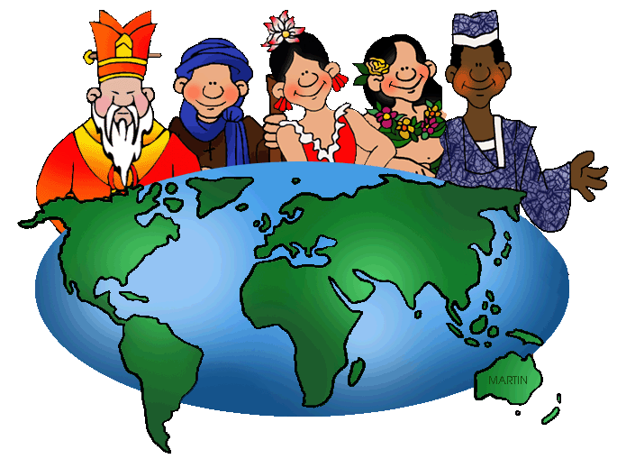
les coutumes et les traditions, ______________ pour l’histoire, …etc.»

We will be posting all of the tiles together to create a cultural mosaic on the bulletin board. Make your tile stand out from the rest!

Liste de contrôle:

Éléments requis (visuellement) |  | Éléments requis (à l’écrit)
Ton nom au verso |  | Present yourself appropriately
Symbols/images representative of the seven elements of culture required |  | Describe yourself appropriately using a minimum of five adjectives
Ethnic backgrounds mentioned and represented |  | Appropriate adjectives used and made to agree
Languages spoken mentioned |  | Culture structure followed
My best effort put forward |  | New vocab researched

Grille d’évaluation : Nom : _____________________

Note | Contenu de la mosaïque culturelle
/K2  /K2  /K5  /K2  /K2  /K7 | 1) Required Elements: your mosaïque culturelle must contain at least these elements:  - All text en français  - Presentation of self using appropriate vocab and info (Greeting, name, age)  - Description of self using a minimum of 5 appropriate adjectives (phys., personality)  - Mention and representation of ethnic backgrounds (Ils viennent de… They come from)  - Mention and representation of languages spoken  - Mention and representation of seven cultural elements
/A5  /A5 | 2) Written Language  - Syntax (Grammar): above components are used correctly  - Orthographic Control (Spelling): words are spelled correctly
/C5  /C5 | - Communication  - Paragraph is effective in communicating personal cultural elements  - Complexity  - Range: varying words and structures are used throughout – use of resources provided in class (including teacher and peer-tutor!) and NOT a translator
/T3  /T3  /T4 | 5) Effort and Creativity  - Tile is neat and professional-looking  - Symbols and images are attractive  - Effort and care are evident, no pencil
 | /K20 | /A10 | /C10 | /T10
Commentaires :
TOTAL: 50 POINTS
