FSF2DB
Mme W-G
Une lettre de présentation et un CV – Vocabulaire

Une entreprise – a company
Soumettre – to submit
La candidature – job application
À temps partiel – part time
À plein temps – full time
Récemment – recently
Acquérir – to acquire
Une compétence – an ability
Une aptitude – an aptitude
Ce qui m’a permis de – which allowed me to
Ce domaine – this field
Apprendre – to learn
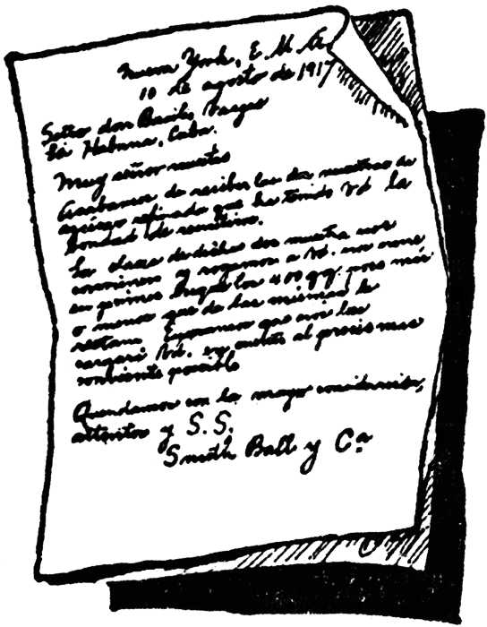
Rejoindre – to reach by phone
Trouver – to find
Les recherches – research
Un poste – a position
Suivre – to follow
Un cours – a programme
Davantage – more
Remercier – to thank
Ainsi que – as well as
Un salaire – a salary
Être employé – to be employed
Afin de – in order to
Mener – to lead

Plusieurs – several, many
Un concierge – janitor, custodian
Une équipe – a team
Connaissance pratique – working knowledge
Dactylographie – typing
Un mot – a word
Un serveur/une serveuse – a waiter/waitress
Le hockey de champs – field hockey
Le centre d’accueil – welcome centre
Fournir – to supply

