Kyoto climate change treaty sputters to a sorry end
Kyoto Protocol aimed for 5% cut in carbon emissions — instead, we got a 58% increase
By Max Paris, Environment Unit, CBC News
Posted: Dec 31, 2012 6:24 AM ET Last Updated: Dec 31, 2012 10:21 AM ET
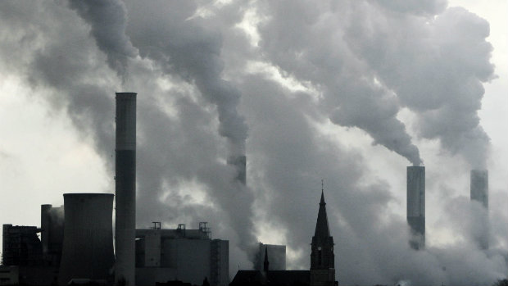
The tower of a church is seen between the smoke-billowing chimneys of the brown coal power plant Frimmersdorf in Grevenbroich near Duesseldorf, Germany. (Frank Augstein/Associated Press)
The controversial and ineffective Kyoto Protocol's first stage comes to an end today, leaving the world with 58 per cent more greenhouse gases than in 1990, as opposed to the five per cent reduction its signatories sought.
From the beginning, the treaty that was adopted in 1997 in Kyoto, Japan, was problematic. Opponents denied the science of climate change and claimed the treaty was a socialist plot. Environmentalists decried the lack of ambition in Kyoto and warned of dire consequences for future generations.
But the goal of the treaty was simple.
"We hoped that we would be able to reduce greenhouse gases substantially, but that it was a first step," explained Christine Stewart, the Liberal environment minister who negotiated in Kyoto on Canada's behalf.
The Kyoto Protocol was an initiative that came out of the 1992 Rio Earth Summit. It recognized that climate change was a result of greenhouse gases created by human industrial activity. The idea was that rich nations, which had already benefited from industrialization, would reduce their greenhouse gas emissions in the first part of the treaty and developing nations would join in later.
Although the protocol was adopted in 1997, it didn't come into force until 2005. In the intervening eight years, countries set reduction targets for themselves and ratified the agreement.
"At the time we didn't realize how complicated it would be to get the Kyoto Protocol ratified and for it to enter into force internationally," said Steven Guilbeault, co-founder of Equiterre, a Montreal-based environmental charity.
Problems from the beginning
Right off the bat, there were problems. The U.S., the world's biggest emitter at the time, signed up but never ratified.
And Canada ratified the treaty but with targets that were unachievable in the opinion of many.
'If we ratify this thing, we'll never hit our targets.'—Bob Mills, former Reform and Conservative MP
Bob Mills was a Reform Party MP from Alberta who went to Kyoto with the government. He was in Johannesburg five years later when the country agreed to reduce emissions to six per cent below 1990 levels.
"If we ratify this thing we'll never hit our targets," Mills warned Liberal Prime Minister Jean Chrétien at the time, because he was worried Canada's international reputation would take a hit.
To his disappointment, Mills was right. As 2005 rolled around, Canada was nowhere near to having a plan and our emissions were rising. When he entered government a year later, the Conservatives started to lay the groundwork for much less ambitious greenhouse gas reductions.
"In 2006, it was a pretty tough situation because nothing really had been accomplished. We had these targets in front of us, they were impossible to hit," he said.
Taking a pass on Kyoto targets
And so, Canada's new government decided not to bother. They worried about the harm it would cause Canada's economy and the fact that only developed nations had to cut back while economic up-and-comers like China, India and Brazil could pollute as much as they wanted.
"We would have to pull every truck and car off the street, shut down every train and ground every plane to reach the Kyoto target the Liberals negotiated for Canada," argued Conservative Environment Minister Rona Ambrose in 2006.
Instead, the Conservative government opted to begin a long process of overhauling all of Canada's environmental legislation. That meant scaling back on Kyoto commitments that couldn't be met.
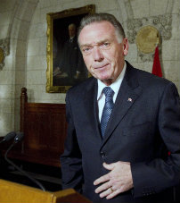
Canada announced to the world that we wouldn't be able to meet our Kyoto targets in 2007. Three years later we set new, easier-to-hit targets — 17 per cent below 2005 levels — that keep us in line with the Americans.
'Kyoto, for Canada, is in the past'
The final nail in the coffin for Canada's involvement in Kyoto went in on Dec. 13, 2011.
"Kyoto, for Canada, is in the past," announced Environment Minister Peter Kent at a news conference in Ottawa soon after he got off the plane from a climate change conference in Durban, South Africa. Kent gave one year's notice and, as of Dec. 15 this year, Canada was no longer a party to the Kyoto Protocol.
While there is plenty of blame to be shared between the Liberals and Conservatives for Canada's failure to meet its targets and remain in Kyoto, the problem of climate change remains a growing threat.
"There is building evidence that, in fact, climate change is accelerating. It's closer than we had thought earlier … we are running out of time," worries John Stone, a Canadian climate scientist and a member of the Intergovernmental Panel on Climate Change that shared the 2007 Nobel Peace Prize with former U.S. vice-president Al Gore.
If there is anything good that came out of the Kyoto experience, it is that the issue it tried and failed to tackle is now top of mind, says Guilbeault.
"That's probably one of the biggest accomplishments of the Kyoto Protocol, is making climate change something that's part of our everyday life."
Some countries have signed on to a second round of Kyoto commitments beginning Jan. 1, 2013, and stretching through to 2020, but they only represent 15 per cent of current world emissions.

