Géo9I

Naked Science: Colliding Continents

- When was the Earth created? How was it created?

- What two elements, because of their density, were pulled to the middle of the earth to create the core?

- What two elements, because of their density, rose to the surface of the earth to help create molten rock?

- Why was the earth’s surface so dynamic in the early stages of the Precambrian era?

- What was missing from the crust after its creation in the early stages?

- What type of igneous rock formed the nucleus of the continents? This rock was less dense and did not sink to the bowels of the earth.
- With what type of rock crystals can they determine the age of the rock?

- What is a craton?

- How is plate tectonics driven? Where does it get its energy?

- What creates convection currents?

- In what country can you actually see the Earth’s crust being pushed apart?

- What is Vaalbara?

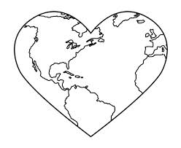
- What is a rift valley? Where is the Great Rift Valley located?

- What was the name of the last Supercontinent?

- Why was the climate of Pangaea so radically different throughout the seasons?

- What was the name of the largest mass extinction known to man? Why did it occur?

- When did Pangaea start to break up?

- Which European mountain range was created at a collision zone?

- Which Asian mountain range was created at a collision zone?

- What is the newest land created between North and South America?

- What happened when the Pacific and the Atlantic oceans were cut off from one another?

- What natural disasters are created by tectonic plate movements?

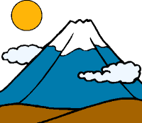
- What will be the name of the final supercontinent?

