Stowaway sneaks past Toronto airport’s security, hides in plane
Postmedia News Apr 18, 2012 – 9:56 AM ET
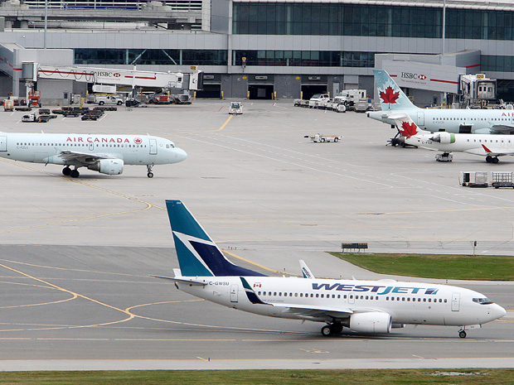
Peter J. Thompson/National Post
File photo of Toronto's Lester B. Pearson Airport taken in October 2010
- Comments
- Email
- Twitter
- inShare2

Police and airport officials are investigating how a man managed to sneak past security at Toronto’s Pearson International Airport and hide in an overhead bin on a Panama-bound flight.
Peel Regional Police Const. George Tudos said police received a call at Monday morning from airport authorities, saying someone had made their way into a secure part of the airport. He did not have information on what tipped airport officials off to this breach.
The suspect was found on a plane about a half-hour later as a canine unit searched the area.
“We’re not disclosing exactly how he did it,” Tudos said. “We are aware of how he did make it across security checkpoints and into the secure area, but . . . it’s not something that we’re going to be releasing.”
The Greater Toronto Airports Authority said the suspect was located on board a Copa Airlines aircraft and no explosives were found.
Trevor Kendall, 33, a Canadian of no fixed address, has been charged with mischief over $5,000, break-and-enter into a plane, endangering the safety of an aircraft and obstructing police.
In April 2009, then-transport minister John Baird criticized security at the Toronto airport after he and Liberal Sen. Colin Kenny were able to walk onto the tarmac and other restricted areas without drawing attention from airport security or being asked for proper credentials.
Pearson is Canada’s busiest airport, handling more than 33 million travellers last year.
With files from National Post staff

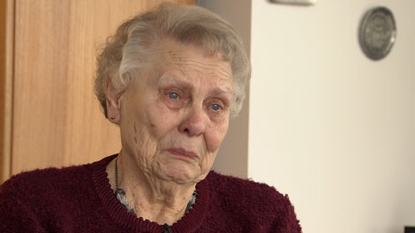
Woman, 82, 'humiliated' by airport security

Cancer survivor Elizabeth Strecker says she was humiliated by security workers at the Calgary airport on Jan. 13, 2011.
Date: Thu. Jan. 13 2011 10:51 PM ET
An 82-year-old woman says she was humiliated by airport security who forced her to reveal her gel prosthesis during a recent public pat-down at Calgary's airport.
Elizabeth Strecker, who was flying to British Columbia after visiting her children last week, says that she will never fly again following the incident.
"It was terribly humiliating and embarrassing for me," she told CTV British Columbia in an interview.
Her ordeal began as Strecker was going through security checks at Calgary's airport.
But when a pin in her leg set off a metal detector, she was directed to a body scanner.
Next, she was asked if she was carrying any liquids or gels, which are barred from flights unless they are in small amounts.
When asked, Strecker demurred: "I didn't think I had to tell the whole world I had a mastectomy."
Strecker lost a breast to cancer, and now wears a gel prosthesis instead of an implant. However, the body scanner picked up the prosthesis, which created a problem with security, said Strecker.
"I heard someone say ‘whatever she said isn't true,'" Strecker recalled. Shortly after that claim from security, Strecker said she was then subjected to a thorough body search.
"Then she started to touch me everywhere."
While Strecker said the pat-down was intrusive, she is especially concerned over the accusation that she would lie to security.
"They make an 82-year-old woman cry like a baby," she said, noting that being described as "a liar or something" was unsettling.
"I came home looked in the mirror and said, "do I really look like a terrorist?'"
Transport Minister Chuck Strahl said this week that the scenario "sounds completely unacceptable."
Despite increasingly stringent security at Canada's airports, Strahl stressed that airport security have a legal obligation to treat travellers with respect.
He also added that any traveller who feels they have been treated poorly should report any wrongdoing.
"When that sort of thing happens, they should file a complaint. We should know about it and there should be action taken."
Strecker said she will report the incident officially. She is also seeking an apology.

With a report from CTV Vancouver Chief Rob Brown
Apparent security breach irks air traveller
OTTAWA—In an apparent breach of one of the key aviation security rules in place in Canada since the 1985 Air India crash, a business-class passenger travelling from Vancouver to London-Heathrow says Air Canada officials loaded his two pieces of luggage onto a flight that he missed.
The incident, which Transport Canada says it is taking “very seriously,” comes just days before the anniversary of the 9/11 terror attack and when Transport Canada has asked air carriers, aerodrome operators and screening officers to exercise increased vigilance.
Gantcho Mantchorov, a U.K.-based data security consultant, had been scheduled to fly Monday night to Edmonton, where he was to connect with Air Canada Flight 898 to London. He missed his Vancouver flight due to illness.
“I’m just totally in shock, to be honest, that somebody took a decision to fly,” Mantchorov told the Toronto Star by phone on Tuesday from the Vancouver airport.
He said he told the baggage agent “Are you telling me it’s crossing the Atlantic without me? (...) This is not supposed to happen.”
After passing through passenger security screening about 35 minutes before his Monday evening flight, he had a severe indigestion attack and arrived at the gate about five minutes before the scheduled departure time. A frequent flyer, he was unconcerned when told the flight had left and that he had to rebook.
However, after rebooking, Mantchorov went to claim his golf bag and suitcase at the baggage handling area. There, an agent told him he would have to retrieve his bags upon arrival in London, even though his original flight was connecting through Edmonton — another chance for Canadian officials to offload them.
Strict passenger-bag match requirements have been in place in Canada ever since the June 1985 crash of Air India flight 182 off Ireland. That flight had originated in Vancouver and crashed in the ocean when a bomb exploded, killing 329 people. Indeed, Canada’s luggage-passenger rules were stricter than America’s until the September 2001 attacks.
Mélanie Quesnel, a spokesperson for Transport Canada, said in an email that the rules were introduced for international flights starting in June 1985, and were extended to all flights in October 2001. She declined to say how often such incidents occur.
“For security reasons, we do not disclose the specifics of the baggage-passenger match regulations. However, as the safety and security of the travelling public are of utmost importance to the government of Canada, we take this incident very seriously and will follow up to determine whether any security regulations were contravened. Transport Canada also conducts inspections of air carriers to verify compliance with regulated requirements including passenger-baggage match.”
She said air carriers contravening these requirements are liable to a fine up to $25,000.
Air Canada called Mantchorov Monday night to say the luggage was taken off the plane in Edmonton, and was to be sent to Calgary, where Mantchorov planned to pick it up and travel onward to London on Tuesday. However, after the Star began making inquiries, Mantchorov learned his Calgary flight was cancelled. He was rebooked through Montreal, and late Tuesday, he no longer knew where his luggage was.
“My concern is the bags should not travel ahead of the passengers. You could have anything in the bags,” he said.
Air Canada spokesman Peter Fitzpatrick replied: “We are are looking into this matter and the specific circumstances of the case so we are not able to comment, or even confirm a security breach actually did occur.”
He said “passenger baggage mishandling does occur from time to time at all airlines.”

Security breach at Sydney Airport forces passengers from planes
SYDNEY Airport's Qantas terminal has been closed and passengers ordered off planes after a security scare.
Two people walked into a secure area of the Qantas-managed T3 domestic terminal without being properly screened, forcing the terminal's evacuation.
As a result, Qantas said it would have to put all passengers through security checks again.
Twelve flights have been delayed and thousands of travellers affected.
Qantas spokesperson, Olivia Wirth, said the airline was sorry for the inconvenience.
"We do apologise, this shouldn't have happened," she told Macquarie Radio.
"We are trying to get to the bottom of this... the good news is that we have actually picked it up."
Ms Wirth said that as of 11.30am (AEST) passengers were "getting back on their way".
It is not yet known how the two people got past security, but passengers were surprised to find themselves called back from the tarmac.
One traveller told news.com.au he was on a plane bound for Melbourne when the captain announced there had been a security breach and everyone would have to disembark.
Other passengers at the terminal went online to report that planes had been grounded and the terminal closed.
"Two passengers enter secure area in Sydney Airport (domestic) causing all passengers to be rescreened. Will be mass delays," one traveller tweeted.
Another passenger said on Twitter: "Entire Sydney Airport terminal has been evacuated due to a security breach. Looks like I'm not getting home today".
The Australian Federal Police are reviewing security footage, ninemsn have reported.
Meanwhile, in a separate incident, ambulances were called to Sydney Airport after people on an incoming international flight suffered burns when a hot drink was spilled during turbulence.
An ambulance spokeswoman said paramedics assessed five passengers and three crew on their arrival.
Three people suffered minor burns but no one needed to be taken to hospital, she said.

2 Secret Service supervisors ousted in prostitute scandal identified
By the CNN Wire Staff | April 19, 2012
Two Secret Service supervisors who have lost their jobs in a prostitute scandal during a recent trip to Colombia are David Chaney and Greg Stokes, a source familiar with the investigation told CNN National Security Contributor Fran Townsend on Thursday. They are among three people no longer with the agency in the wake of the incident immediately preceding President Barack Obama's trip to Colombia for the Summit of the Americas. They are among 11 total Secret Service employees who are under investigation.

TRAVEL

TSA: Employee's actions led to Newark security breach
January 7, 2010
A security breach at the Newark, New Jersey, airport over the weekend was caused by an officer of the Transportation Security Administration who left his post unattended, an agency spokeswoman said Thursday. Security video shows the officer walking away from his post at Newark Liberty International Airport, about four minutes after he asked an unidentified man in a light-colored jacket to stay behind the rope line. Moments later, the man ducks under the rope and walks the wrong way through security to greet a woman, prompting a security breach that shut down Terminal C for hours and forced the rescreening of thousands of passengers.

Report: 25,000 Security Breaches at U.S. Airports Since November 2001
Newly released Department of Homeland Security documents reveal that there have been 25,000 security breaches at U.S. airports since November 2001.
More than 14,000 of those infractions were people entering “limited-access” areas, while another 6,000 incidents included travelers who made it through security checkpoints without being properly screened. Congressman Jason Chaffetz of Utah, a frequent critic of the Transportation Security Administration (TSA), is overseeing a congressional hearing Wednesday on the security shortcomings. “I think it’s a stunningly high number,” Chaffetz told the Associated Press.
(MORE: Woman Calls TSA Hair Pat Down ‘Racially Motivated’)
But Transportation Security Administration spokesman Nicholas Kimball told USA Today that the breaches represent a miniscule fraction (just 1%) of the 5.5 billion air travelers who have used U.S. airports in the past 10 years. He also added that the term “breach” can mean a number of things and that “many of of these instances were thwarted or discovered in the act.”
The TSA has been under fire in recent months for several high-profile breaches. The most recent incident occurred when a cleaning employee discovered a stun gun on a JetBlue plane that had landed in Newark, having flown from Boston. In early July, a Nigerian national was found to have flown cross-country using an expired boarding pass in someone else’s name. And in June, the TSA concluded a six-month investigation at Honolulu International Airport, recommending that 36 screeners be fired for failing to follow proper security procedures in a recurring shift.

